Truck Parking
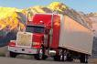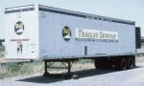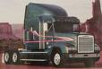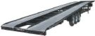
$95 Per Month
-Truck and Trailer
-Near Apple Valley Airport
(Dale Evans Pkwy and Corwin Rd Vicinity)
5 Acres ∙ Very Secure

$55 Per Month
-RV’s, Campers, and Boats
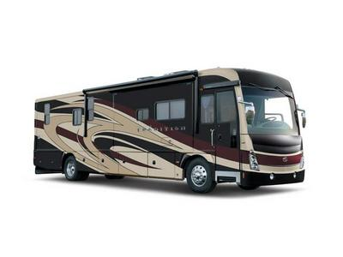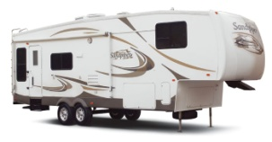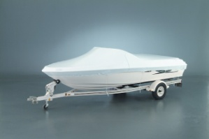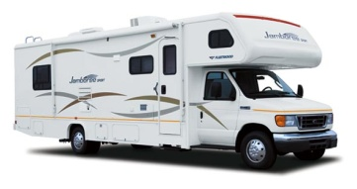

$40 Per Month
-Cars and Pickup Trucks

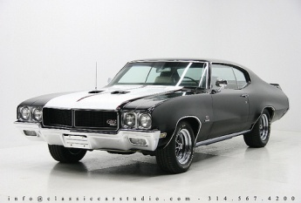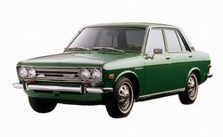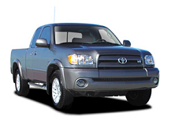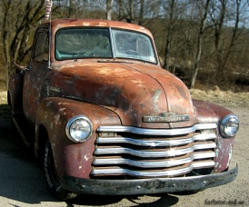

*you name it, we store it*
Contact Rick Myhro
(951) 522-2122
Land for Lease:1.25 Acres ∙ Zoned Industrial ∙ Can Park or Store Trucks, Trailers, and Heavy Equipment ∙ $1,800 Per Month

